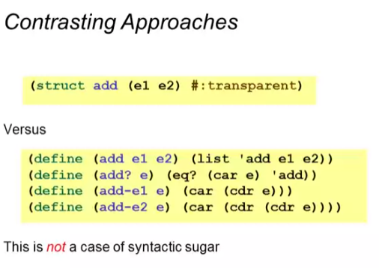

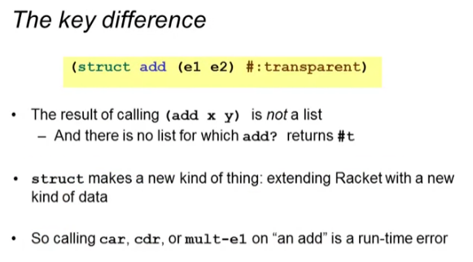

* You do not get a list back!!
* This is good because if you try to use accessing functions it will have an error!

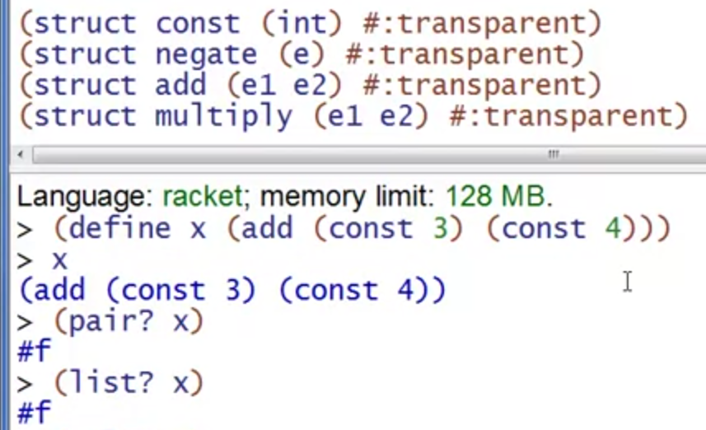

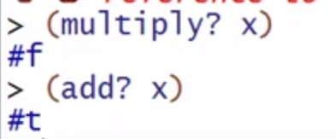

It is only an “add”!

* Nothing will ever type check but the add constructor

Each struct definition adds a new kind of PRIMITIVE data

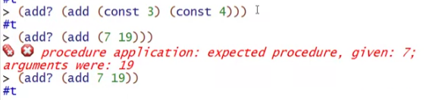

Applying other struct’s accessing functions to our add struct

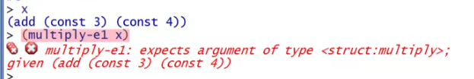



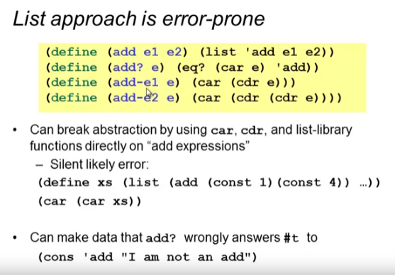

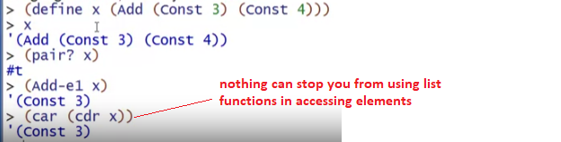

You can even access the elements even if you use other definitions’ accessing functions:



* This is wrong!!
* X is an add and it must not be accessible with multiply definitions
  + This is the main reason why using struct is better!

